Group Members:
Christie Chong (cchong@mit.edu), 15.8731
Catherine DiGennaro (cdigenna@mit.edu), 15.873
Aaliya Hussain (ahsn@mit.edu), 15.8731

A1
Table Function for Workday
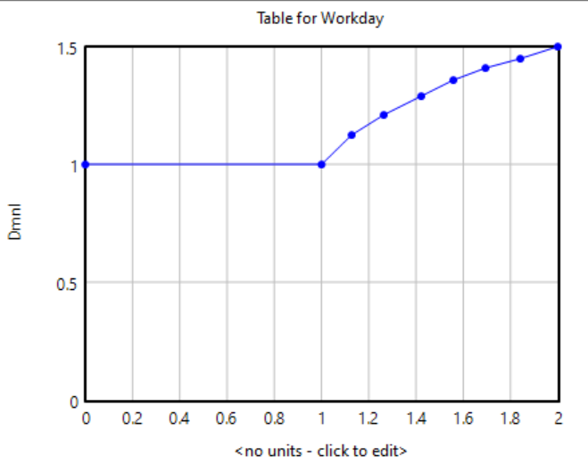
The shape of the workday table function is based upon two assumptions about the LC’s workday policies: (1) the LC does not allow for undertime, and (2) the LC has a “diminishing” overtime policy capped at 4 hours of overtime (which creates a workday of 12 hours, which is 1.5 times the standard workday length). The lack of an undertime policy creates the flat curve at a relative workday value of 1 for schedule pressure values less than or equal to 1, representing the assumption that standard workdays are mandated even when schedule pressures are well below the standard value. The “diminishing” overtime policy creates the logarithmic shape of the curve at schedule pressure values greater than 1, which is based upon the intuition that workers become less and less willing to work additional overtime hours as they take on longer workdays, even as schedule pressure increases.

Table Function for Time per Task
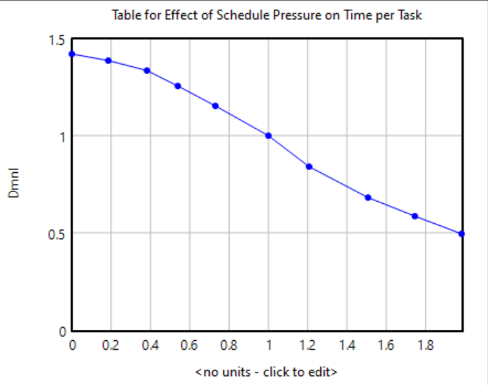
The table function for time per task gives relative workday values ranging from slightly above 1 (with a maximum value of around 1.4) to slightly below 1 (with a minimum value of around 0.5) based on the intuition that workers can make slight adjustments to the amount of time they spend completing tasks depending on schedule pressure. Workers are assumed to take a small amount of additional time to complete tasks when schedule pressure is below 1 (i.e., below the usual amount) and to save a small amount of time in completing tasks when schedule pressure is above 1, and the maximum and minimum relative values for time per task were extrapolated from Figure 1. The curve is S-shaped because of the assumption that workers can more easily make slight adjustments to the time they take per task in response to schedule pressure and find decreasing or increasing the time per task increasingly difficult as they approach the lower and upper limits.

B1
In response to the 20% step increase in workload (i.e., task arrival rate), the productivity of the LC workers immediately increases by 20%, which allows the workflow system to remain in a stable state of equilibrium. The increase in productivity is due to an increase in schedule pressure, which causes the workday to increase and the time spent per task to decrease, giving workers both longer periods of work time and greater efficiency (i.e., task completion rate). The backlog of incomplete tasks does increase, but the magnitude of the increase is lower than 20% due to the synergistic effects of the changes in workday and time per task. This discrepancy between the increase in the task backlog and the efficiency causes a slight decrease in the time to close cases (i.e., the delivery delay).

B2
The system is able to reach an equilibrium after step increases in workload (i.e., task arrival rate) of less than approximately 200%. At step heights of 200% or greater, however, the task backlog and delivery delays will increase indefinitely (see the figures below); the backlog will increase linearly after reaching a value of approximately 1,500 tasks (700 tasks above the standard value of 800 tasks) while the delivery delay will increase in a simple linear fashion after an initial decrease in response to the shock in demand. The limitations on the system’s ability to adjust to increases in workload are due to constraints in how much workday can increase and time spent per task can decrease in response to increasing schedule pressure from the greater workload. Once workday reaches its maximum value and time per task reaches its minimum value, productivity is effectively maximized, and even as the workload increases, the productivity cannot be further increased to match the growing workload.
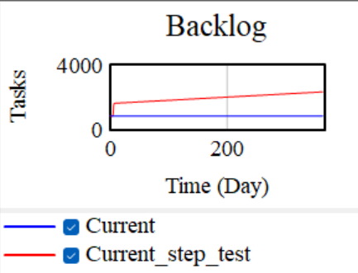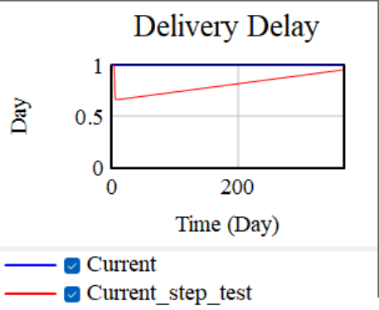

B3
Overall, the system appears to have a high degree of stability to increases in workload (i.e., higher task arrival rate) or decreases in labor force (i.e., higher absenteeism). This stability is due to the ability of LC worker productivity to increase, through longer workdays and lower time spent per task, in response to greater schedule pressure. Decreases in workload, in contrast, produce much less stable behavior due to the lack of undertime, which prevents the workday from decreasing below the standard length.

In the following figure, random noise (with a standard deviation of 0.1) was introduced into the workload (i.e., task arrival rate).
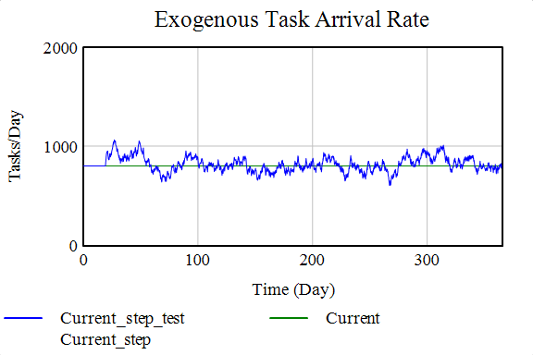
The graph of the backlog demonstrates the greater stability of the system in times of increased workload. While the backlog mirrored both increases and decreases in the workload, increases in workload produced changes in the backlog of much lower magnitude than decreases in workload. The decreases in backlog, unlike the increases in backlog, were amplified relative to the corresponding changes in workload.
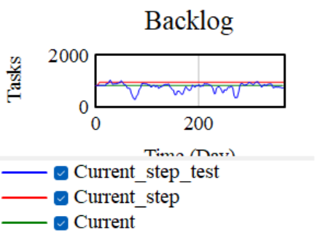
The following graphs of the workday and time per task demonstrate the structural causes of the system’s greater stability towards increases in workload. While time per task changed when workload deviated from the reference value in either direction, workday could only increase above its standard length, meaning that workday could respond to increased workload but not to decreased workload.
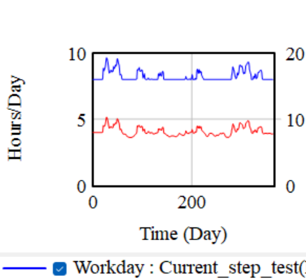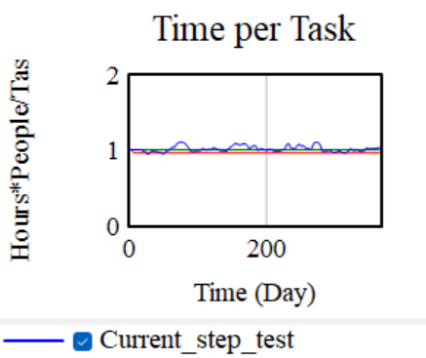

The introduction of noise (with a standard deviation of 0.2) into the absenteeism confirms that the system is also relatively stable and resilient in the face of decreased workforce.
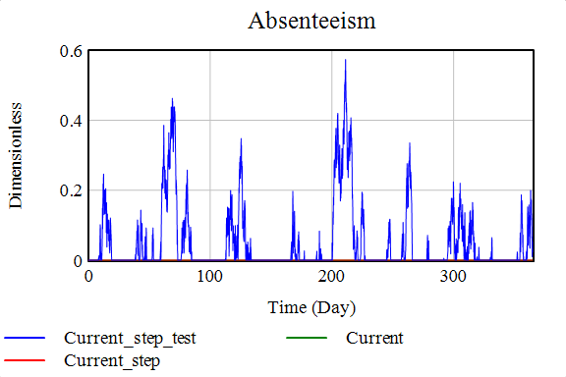
The trends in both the time to close cases (i.e., the delivery delay) and the task backlog match the trends in absenteeism. Spikes in all 3 measures are observed at the same time points, and no additional oscillations or amplifications are observed in either the delivery delay or the backlog.
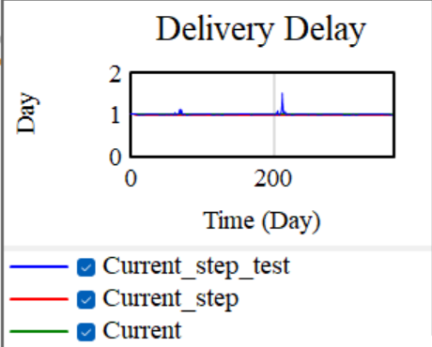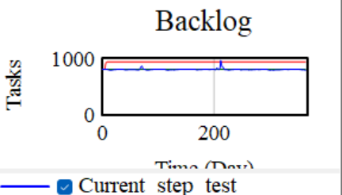
The following graphs demonstrate that workday and time spent per task are again the levers through which the system is able to adjust to exogenous changes. Workday spikes and time per task dips when the absenteeism, delivery delay, and backlog spike, suggesting that the productivity of the non-absent workers can be increased through changes in workday and time per task in response to increased absenteeism. This capacity for productivity adjustments provides the system with its stability towards exogenous changes in absenteeism.
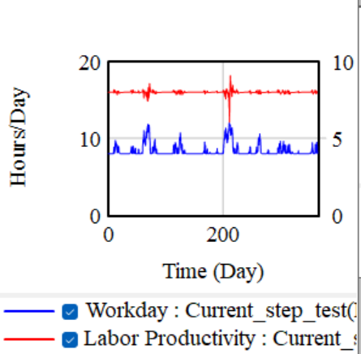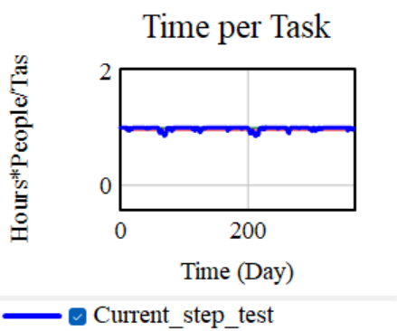

C1
Part 1
The total cross-selling revenue initially increases with the height of the step increase in workload (i.e., task arrival rate), but once a critical threshold (approximately 27%) in the magnitude of the step increase is reached, the revenue from cross-selling decreases. The existence of a critical threshold between increased and decreased cross-selling revenue is caused by the opposing effects of the increased workload on the number of tasks being completed and the average cross-selling revenue (per task). An increased workload will increase the number of tasks that are completed, which will raise the cross-selling revenue because of the increase in opportunities for cross-selling, but will decrease the average cross-selling revenue, which is caused by a decrease in the time spent per task (due to increased schedule pressure) and will lower the cross-selling revenue because fewer cross-sales are made per task.

Initially, the total cross-selling revenue increases because the effects of the increase in the number of completed tasks outweighs those of the decrease in average cross-selling revenue. Once the critical threshold in the workload step increase is crossed, however, the effects of the decline in the average cross-selling revenue begin to outweigh those of the increases in the number of tasks, causing the total cross-selling revenue to decrease.

Part 2
Increased absenteeism decreases the total cross-selling revenue, which decreases the total revenue. The more workers that are absent, the higher the schedule pressure that the non-absent workers experience. To accomplish the same total number of tasks with fewer workers, the remaining workers must spend less time completing each task, which lowers the quality of their work and leads to a decline in the average cross-selling revenue (per task). Because the total number of tasks completed by the workers remains fairly constant, the decline in the average cross-selling revenue causes the total cross-selling revenue to decrease.

C2
Part 1
After the step increase in the task arrival rate (i.e., the workload), the system is able to reach a new equilibrium by around the 500th day.

As the figures below demonstrate, the task backlog, delivery delay, and labor productivity all increase by approximately 20% (the magnitude of the step increase) in response to the increased task arrival rate. The labor productivity reaches its new equilibrium value instantaneously while the backlog and delivery delay increase logarithmically to the new equilibrium value over a period of about 500 days.
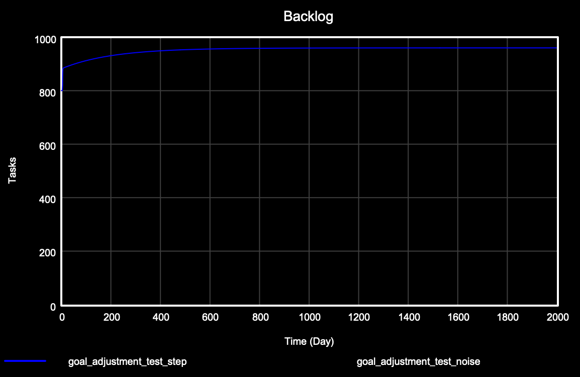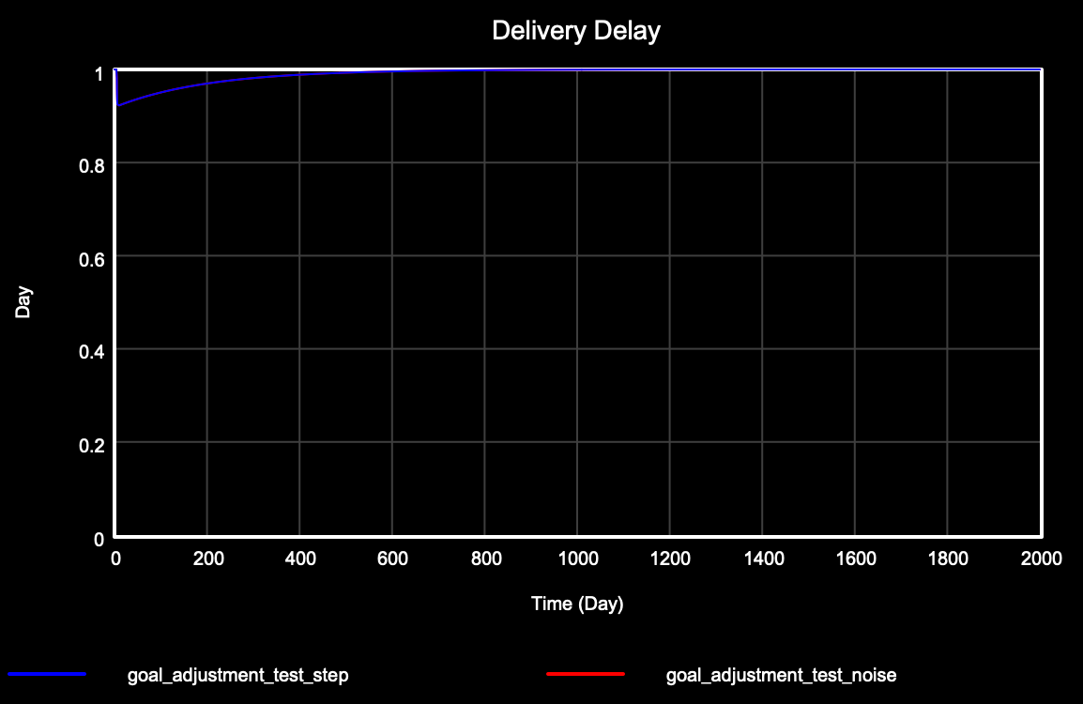
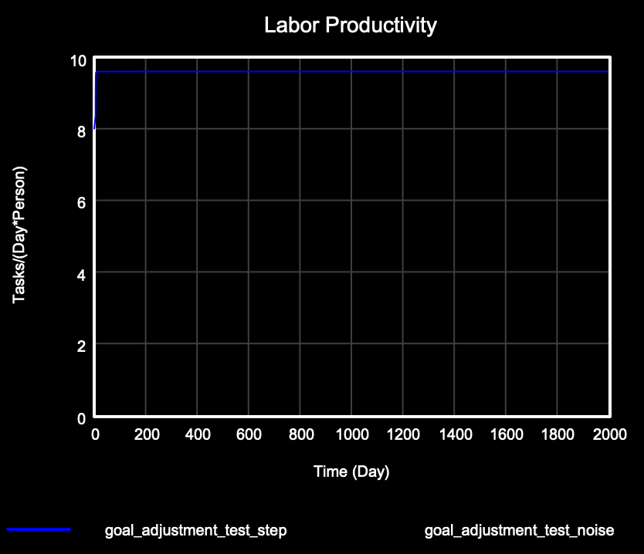
In contrast, the actual time per task and the normative time per task (i.e., the standard time per task) reach new equilibrium values that are approximately 20% below their initial values (see the figure below). The actual time per task is initially lower than the normative time per task, but the normative time per task decreases to the value of the actual time per task once the new equilibrium is reached.
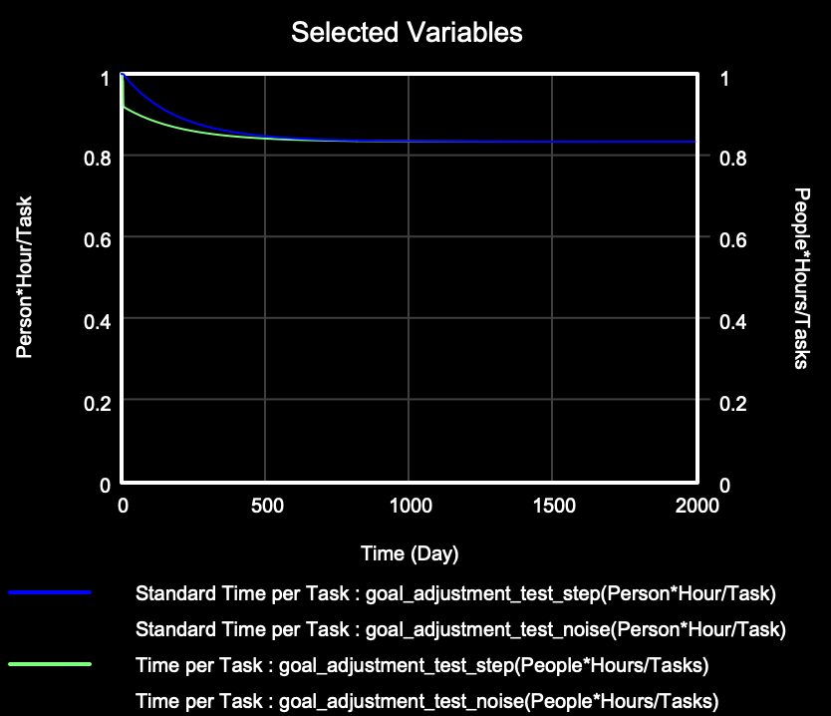

Along with the actual and normative time per task, the average cross-selling revenue per task declines once equilibrium is reached, but the magnitude of the decline is greater than the height of the step increase in the task arrival rate (see the left figure below). This decreases the total cross-selling revenue, causing the total revenue to decrease (see the right figure below).
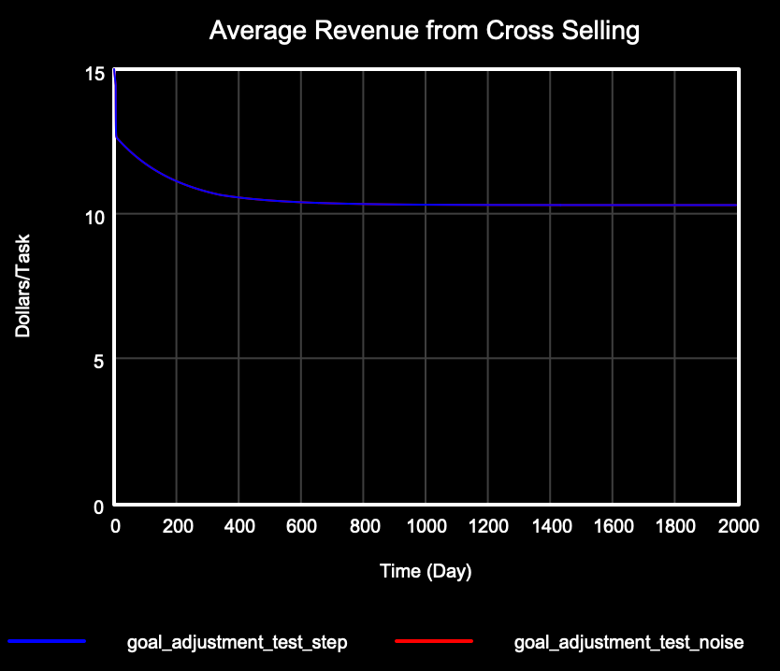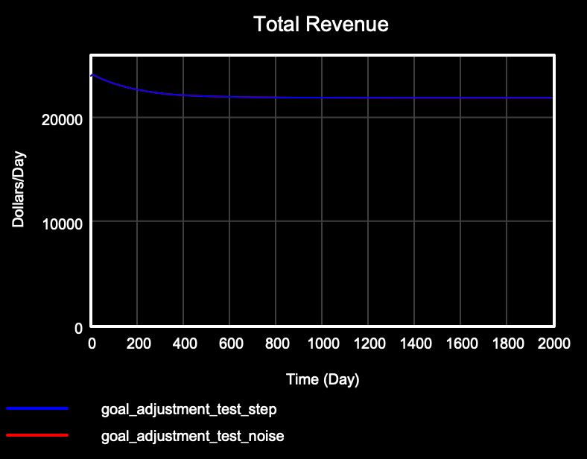

Part 2
The key difference between this model and the original model is that the organizational norms for the amount of time spent doing a task now dynamically adjust to the actual amount of time workers spend completing a task. When the workload (i.e., the task arrival rate) increases, in response to the increased schedule pressure, workers reduce the amount of time they spend completing tasks. Over time, the decreased time spent per task causes workers and managers to adjust their perceptions of the appropriate amount of time spent per task to match the actual amount of time spent per task, leading the normative time per task (i.e., the standard time per task) to decline over time. The causal loop diagram below illustrates the normative time per task adjustment feedback mechanism.
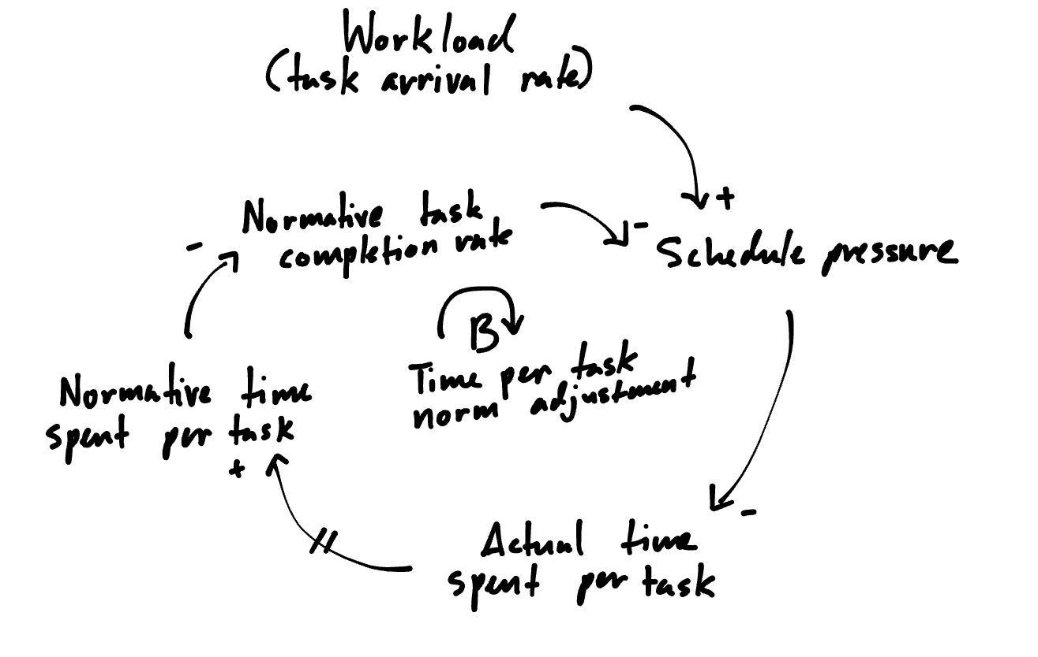

The decreases in the actual and normative time spent per task increases the workers’ productivity as they are able to complete more tasks per a given time period. However, because customer service quality is strongly positively correlated with the amount of time that workers spend with customers, the decreases in the actual and normative time spent per task cause customer service quality to erode. Worse customer service quality leads to fewer cross-sales per task, leading cross-sell revenue and total revenue to decline over time. These declines in customer service quality and cross-selling persist in the new equilibrium because of the decline in the normative time spent per task, which ensures that the actual time spent per task remains low even as the schedule pressure lowers.

Part 3
As the figures below illustrate, the actual time spent per task decreases when absenteeism increases. Higher absenteeism leads to a smaller workforce, which increases the schedule pressure on the non-absent employees to maintain the required level of productivity. The non-absent workers decrease the amount of time they spend with each customer (i.e., the actual time per task) in response to the schedule pressure. After sustained periods of high absenteeism and low actual time per task, the normative time spent per task (i.e. the standard time per task) begins to decrease in order to match the actual time spent per task. The fluctuations in the normative time per task are dampened relative to the fluctuations in the actual time per task due to the delays in the adjustment mechanism.
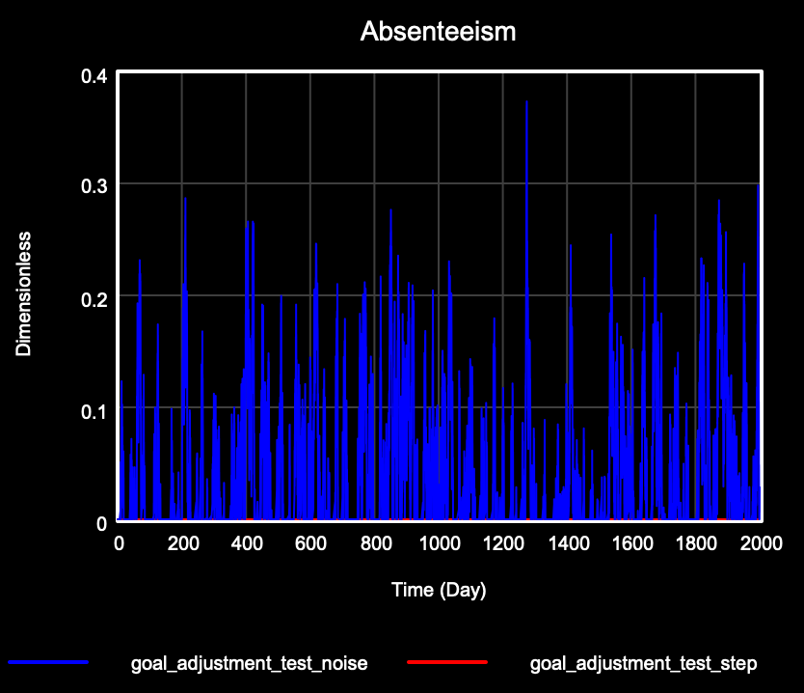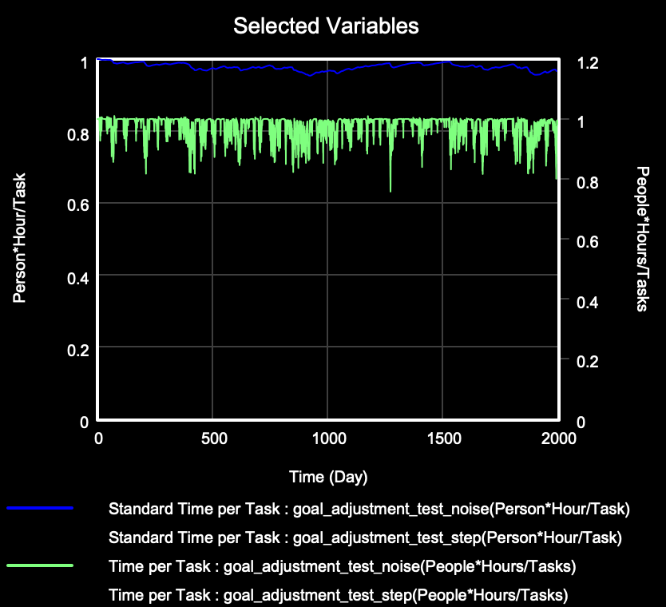

Due to the positive correlation between the actual time per task (i.e., the time spent with each customer) and the perceived quality of customer service, the trends in the average cross-selling revenue per completed task (see figure below) mirror those of the actual time per task. When actual time per task is high, the average cross-selling revenue per task is high, and vice versa.
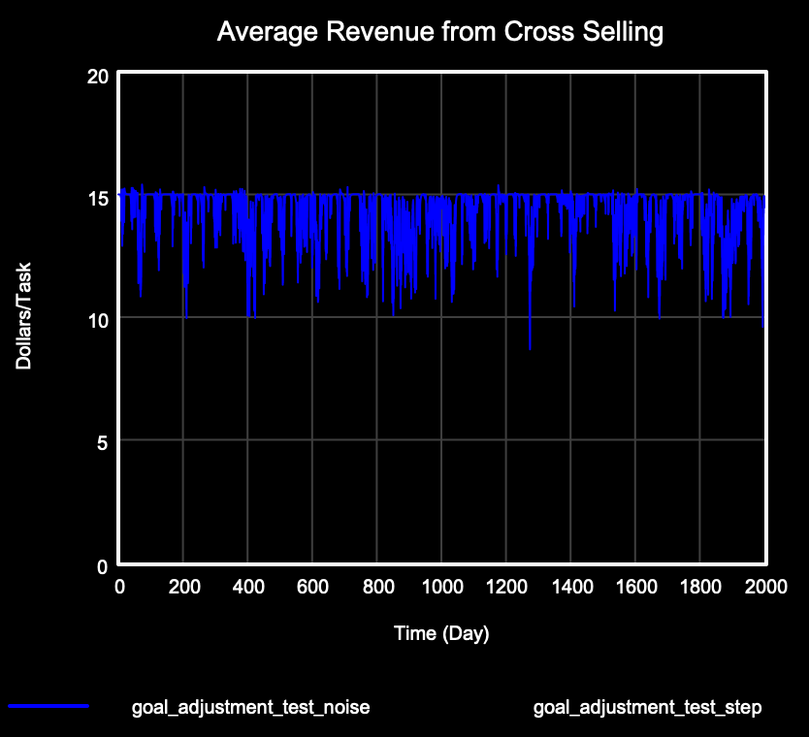

C3
Part 2

A step increase in the task arrival rate (i.e., the workload) of 20% and 80% (an extreme case) is applied to the model to test how it varies under different step increases.

For both the 20% and 80% step increase, total revenue decreases and eventually reaches equilibrium after sometime. The magnitude of the decrease and the time to reach equilibrium both depend on the magnitude of the step increase: the greater the step increase in the task arrival rate, the larger the magnitude of the decrease in the equilibrium total revenue, and the longer the system takes to reach the new equilibrium. Total revenue decreases and plateaus to roughly $21,900/day at day 700 after a step increase of 20% (see the left figure below) while the total revenue decreases further after an extreme step increase (80%) to an equilibrium of roughly $19,493/day at day 800 (see the right figure below).
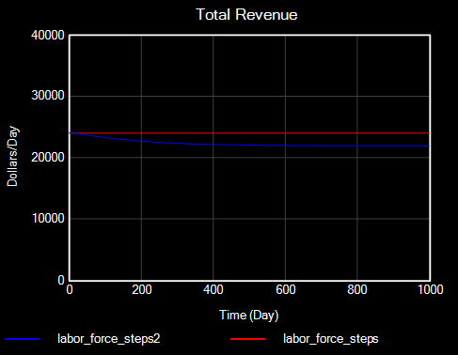
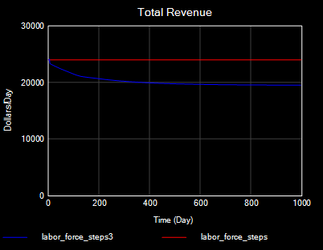

Additionally, desired completion rate (i.e., the maximum productivity of the workers) initially increases sharply before increasing gradually and reaching equilibrium in both cases. The sharp initial increase is caused by increases in overtime and decreases in the time workers spend per task. As the workers become accustomed to spending less time completing each task, the norms for how much time workers and managers expect to spend completing a task (i.e., the standard time per task) decreases to match the actual time spent per task. This produces the gradual rise in the desired completion rate to its equilibrium value. Note that the magnitude of the increase in the equilibrium desired completion is positively correlated with the magnitude of the step increase in the task arrival rate.
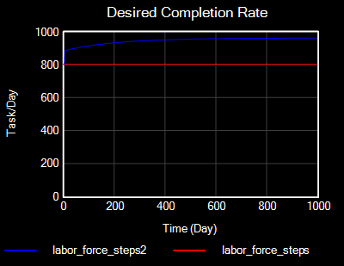
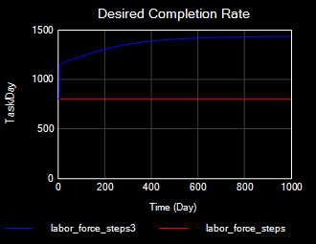

After a step increase of 20%, labor productivity increases immediately by 20% to a new equilibrium of roughly 9.6 tasks per day * people. Similarly, an extreme increase in incoming tasks of 80% also causes labor productivity to increase by a magnitude that matches the step increase of incoming tasks. This increase can be explained using the work availability feedback loop: an increase in backlog increases the maximum completion rate and thereby the task completion rate. Since task completion rate is positively associated with labor productivity and the labor force remains constant, labor productivity also increases.
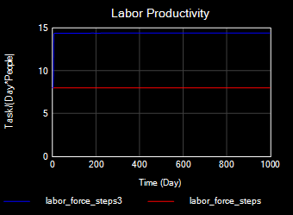
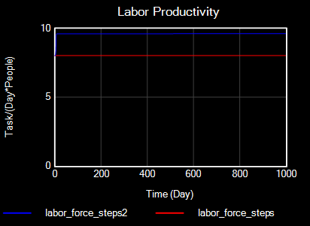

In both cases, the labor force remains the same at 100 people. Both cases see an increase in backlog and a decrease in time per task. Since time per task is positively correlated with revenue made from cross selling, revenue decreases as seen in the graphs above and thereby the budget allocated to LC. Labor force is determined by how many people are hired, and the hiring rate, in turn, is dependent on the budget available. Hence, facing insufficient budget, the LC does not hire any new workers and the labor force remains constant.
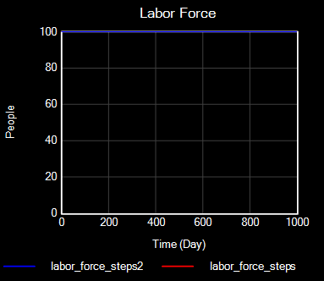

This phenomenon is also reflected in the desired number of people. In both cases, the desired number of people decreases and eventually reaches equilibrium at a value lower than the original baseline value despite the increase in the desired completion rate. This is due to the decrease in the budget available for hiring new workers, which is driven by decreases in the cross-selling budget due to the customer service quality deterioration that occurs after workers begin to “cut corners” (i.e., spend less time completing each task).
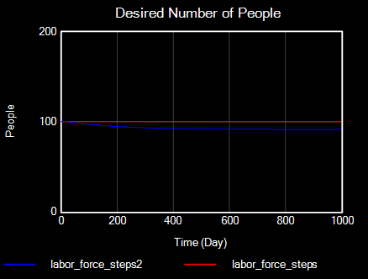
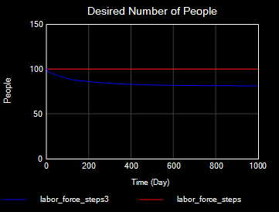

From the results above, LC managers would interpret that workers are cutting corners in order to meet the desired completion rate, which boosts productivity in the short-term at the expense of customer service quality in the long-term. Because the budget available to hire more workers to meet increased demand depends on the customer service quality (due to the links between customer service quality and cross-selling), this causes the LC to experience declines in revenue after sudden increases in demand.

Part 3
A ramp in tasks arrivals with a slope of 0.0002/day was added to the model.

In this model, revenue experiences a more linear and gradual decline compared to a step increase but does not seem to reach an equilibrium within the given timeframe. This is because the increase in incoming tasks is more gradual compared to a step increase; hence, this gives time for the LC to respond to increases in demand before the available budget for hiring declines due to worsened customer service quality. The LC responds to the increase in demand by hiring more people.

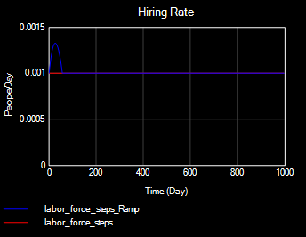

Despite this, total revenue still decreases over time because the hiring rate cannot fully address the growth of the customer base quickly enough for the workers to not have to resort to corner-cutting (i.e., lowering the time they spend per customer) in order to maintain the desired completion rate (i.e., the desired productivity level). Hence, workers will still have to spend less time with customers in order to reach the desired completion rate, increasing their labor productivity at the expense of customer service quality. This causes the total revenue to decline due to decreases in cross-selling.
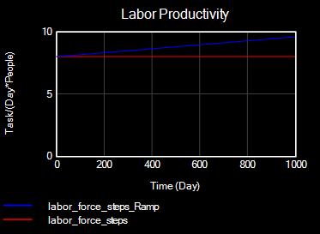
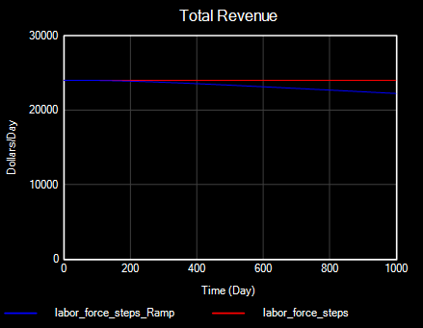

Part 4
In the graphs below, random noise in absenteeism, at a standard deviation of 0.1, was added to the model.
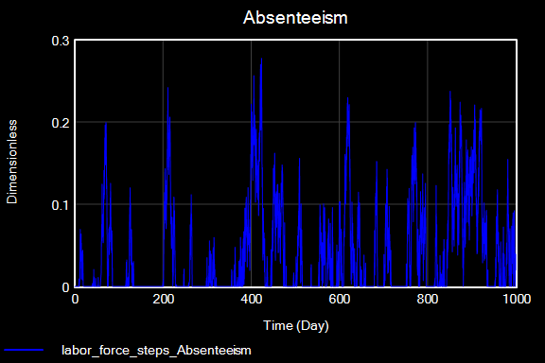
Labor productivity spikes on days of high absenteeism since absenteeism shrinks the number of workers available to serve customers on a given day. Hence, workers would have to work faster (i.e., reduce the time spent per task) in order to meet company goals (i.e., the desired completion rate), decreasing opportunities for cross-selling and thereby total revenue.

Additionally, the hiring rate in this model is equivalent to the attrition rate at 0.01 people/day. This indicates that the LC hires to replace people who have left the LC and maintain a constant labor force of 100 people rather than take into account the high levels of absenteeism the LC experiences. This is likely caused by the constraints on hiring posed by the budget.
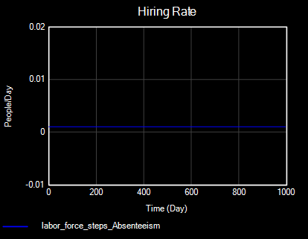

D
We added two key reinforcing feedback mechanisms associated with burnout: the impact of burnout on the workforce attrition rate (“Quitting from Burnout”) and the impact on the total labor productivity (“Fatigue from Burnout”). In both feedback mechanisms, an increase in schedule pressure leads to an increase in the overtime hours contributed by the workers. As the workers are required to complete more and more overtime hours, they begin to experience increasing levels of burnout. The elevated burnout levels both directly and indirectly (by increasing the attrition rate) lower the total productivity of the workforce, decreasing the number of tasks that are completed and further elevating the schedule pressure. These mechanisms are illustrated below in the causal loop diagram.
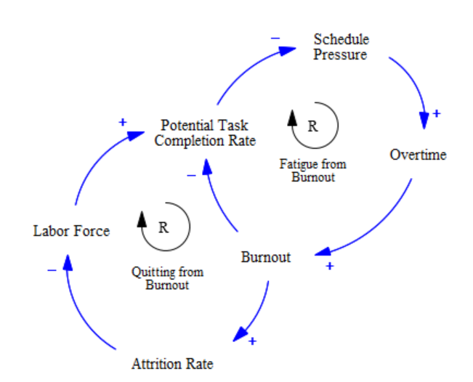

The following table lists the new variables added (and the existing variables modified), the units of measurement, and the operationalization (i.e., the equation or table function):
Variable Name | Units | Operationalization
Burnout | Dimensionless | Equation: MIN(1, MAX(0, Effect of Schedule Pressure on Workday-1))
Table for Burnout on Productivity | Dimensionless | Table function:  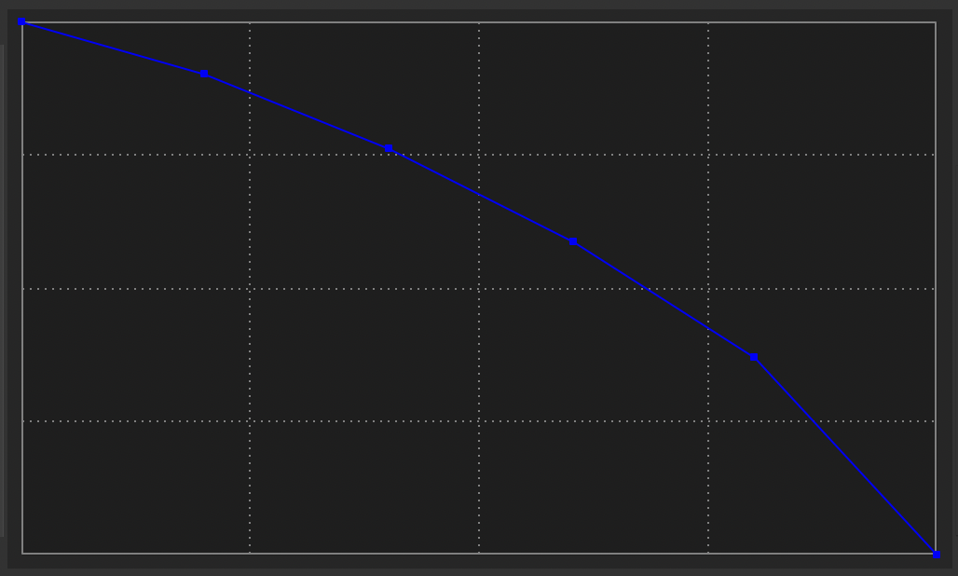  y-axis = normalized productivity (from 0-1)  x-axis = normalized burnout (from 0-1)
Effect of Burnout on Productivity | Dimensionless | Equation: Table for Burnout on Productivity(Burnout)
Potential Completion Rate (modified) | Tasks/Day | Equation: (Net Labor*Workday)/Time per Task*Effect of Burnout on Productivity
Attrition Rate (modified) | People/Day | Equation: Baseline Attrition Rate*(1+Burnout)

Impact on Model Behavior:
For a 20% step increase in the task arrival rate:
In the short-term, the system appears to be slightly less resilient to the effects of a step increase in the task arrival rate (i.e., the workload) compared to one without the burnout. The total cross-selling revenue and the actual time spent per task are lower while the backlog and the delivery delay are higher (see the figures below), indicating worse customer service quality. In the long term, however, the system reaches the same equilibrium.
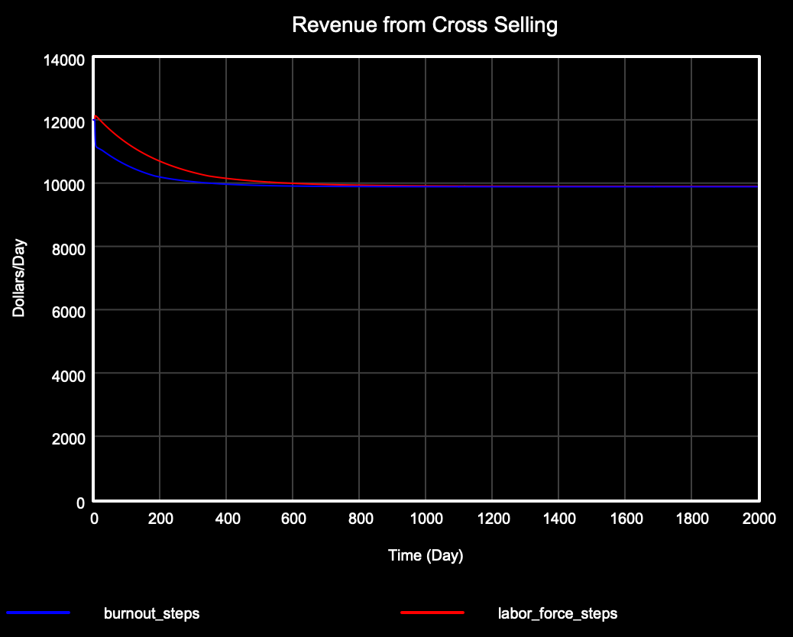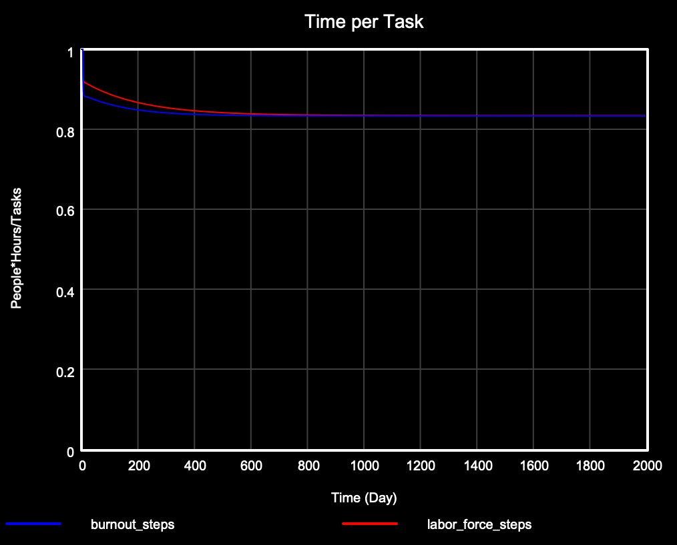
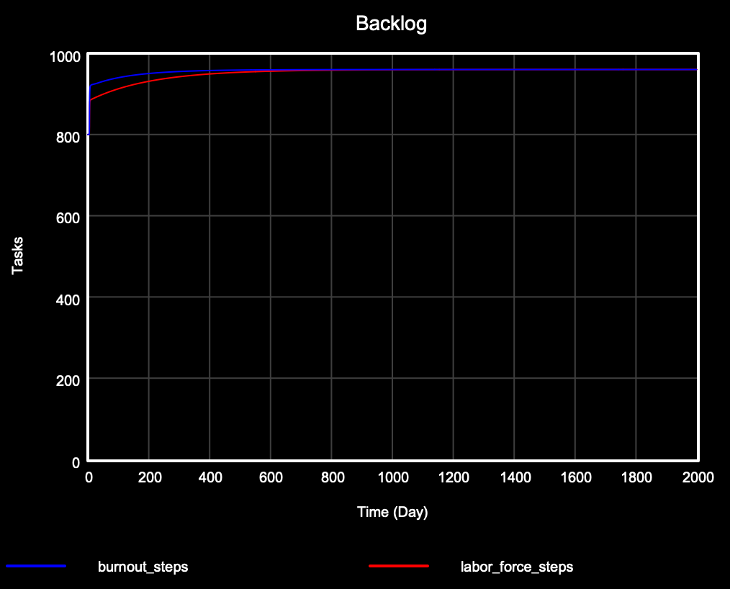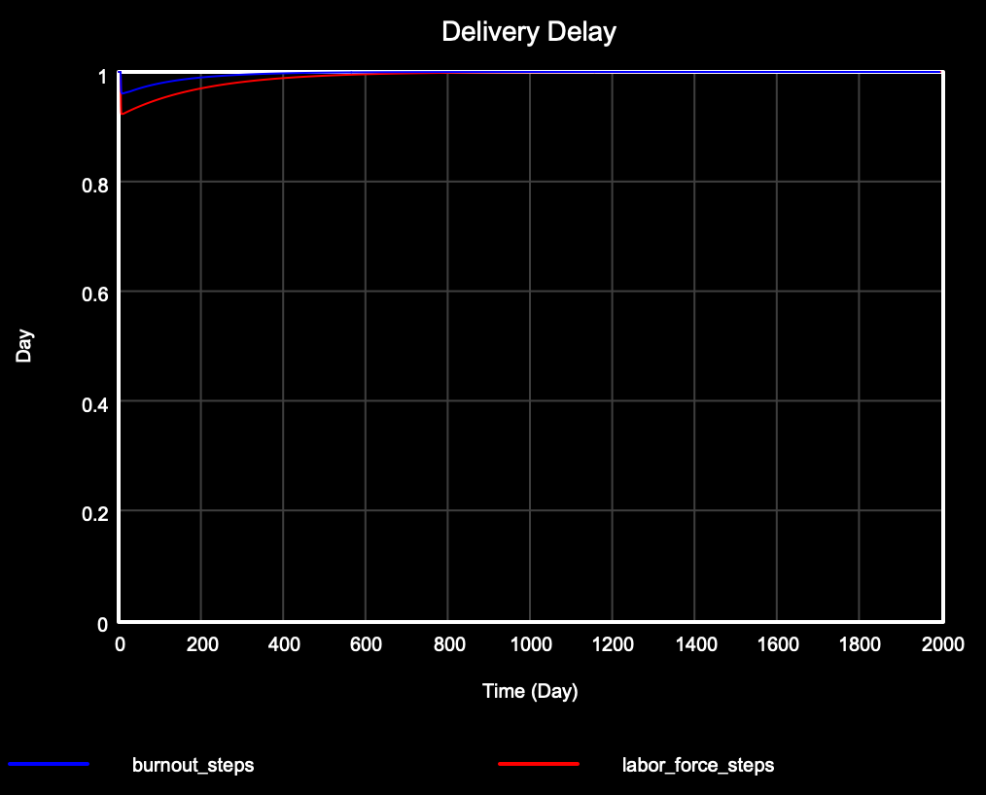
The attrition rate (see the figure below) spiked before declining to the baseline value at around 500 days (rather than remaining constant). This sudden increase in the attrition rate, which is produced by the increase in burnout, is the cause of the above short-term effects. The elevated attrition rate lowered the workforce available to complete tasks, causing a short-term decrease in productivity that harmed the above measures of customer service quality.
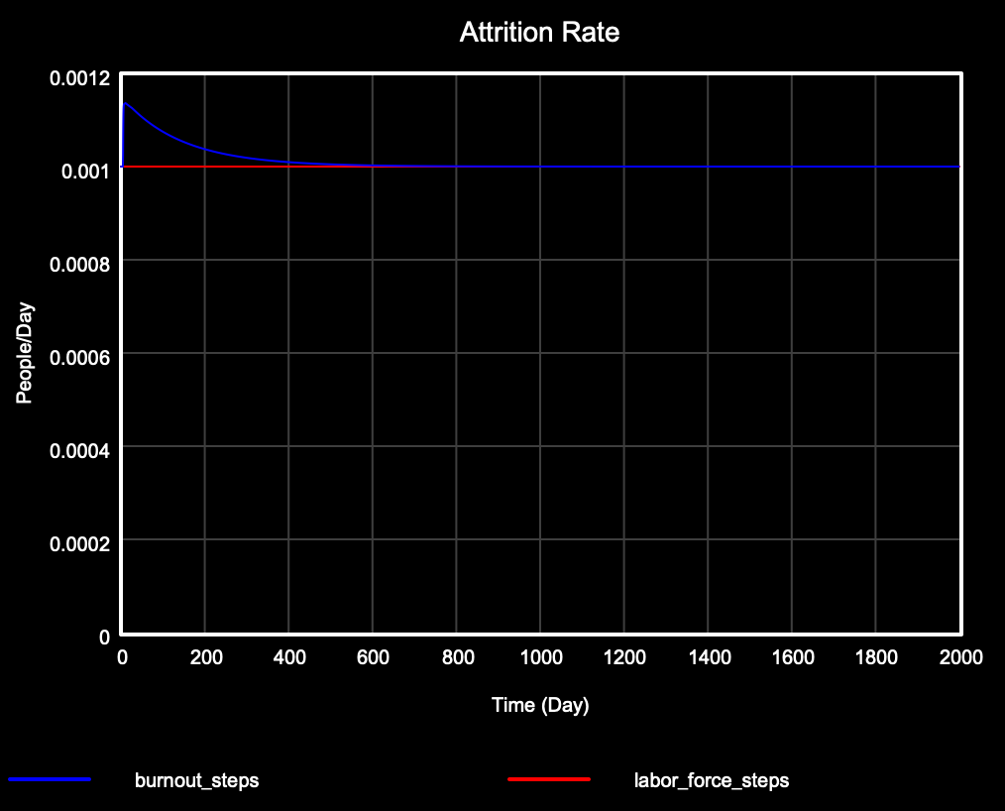

For a ramp of 0.0002/day in the task arrival rate:
Similar comparative results are seen for the two models as in the case of the 20% step increase in the task arrival rate. The key metrics of customer service quality (total cross-selling revenue, time per task, backlog, and delivery delay) are slightly less favorable for the burnout model due to an elevation in the attrition rate.

For random absenteeism (SD = 0.1):
The comparative results are similar to those of the two cases above (the step increase and ramp in task arrival rate). Attrition rate follows the fluctuations in absenteeism (see the figures below), which causes the fluctuations in the customer service quality metrics (total cross-selling revenue, time per task, backlog, and delivery delay) to be amplified in the burnout model relative to the simpler model.
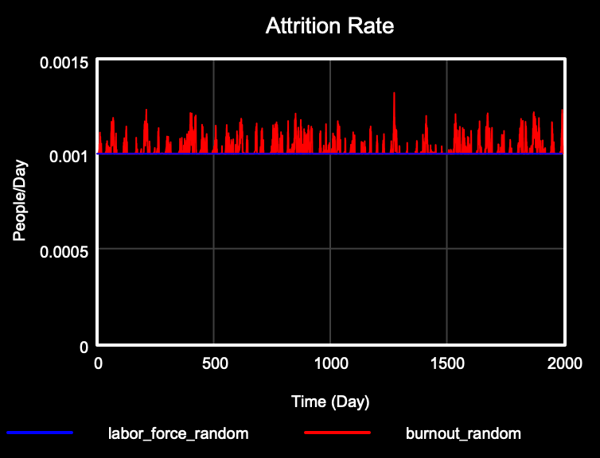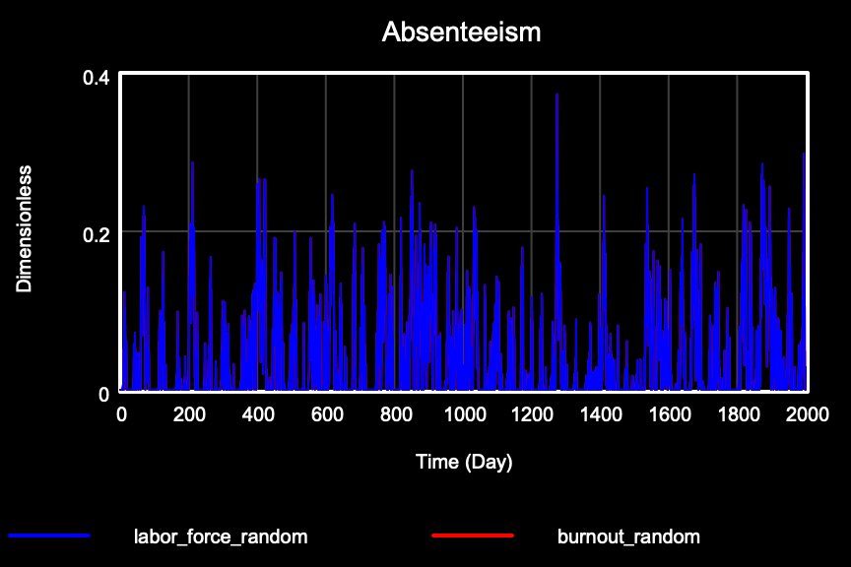

E
UGB could improve the resiliency of the system to fluctuations in customer demand and increase their overall revenues by implementing the following three policies:

First, UGB should allocate a reserve budget for rapid increases in the workforce. If they allocated this budget using a decision rule about what magnitude of demand shock may warrant emergency funding for increased hiring, the budget constraint on the labor force would be looser, and they could reach the desired task completion rate more quickly. Achieving this would weaken both the “cutting corners” and “midnight oil” balancing loops which, in practice, would obviate the need to erode customer service quality by cutting time needed per task and would alleviate the negative impacts on burnout caused by schedule pressure.

Second, UGB should consider making its hiring process more efficient via strategies such as more aggressive recruitment, more streamlined training, and reduced bureaucratic hurdles to hiring. Success in implementing this strategy would have synergistic effects with the first policy recommendation by allowing for even more rapid adjustments to the labor force as needed.

Third, UGB would benefit from adjusting the standard time per task based on the average cross-sell revenue per task. Adding additional stability via this balancing loop would counteract the drift of standard time per task towards the actual time per task, which would prevent short term declines in time per task from degrading into a lower standard for time spent on each task. This would increase revenues from cross selling via an increase in customer service quality.

